Module Name: Student Registration – Grade Calculation

Test Case ID: TC001-05

Website URL: https://gleeful-swan-104344.netlify.app/
● Scenario ID: TC001
Scenario: Verify grade calculation for 95 marks
Test Steps:
- Enter student name
- Enter roll number
- Enter student marks
Test Input:
Name: Rahul
Roll No: 101
Marks: 95
Expected Result: Registration successful; Grade A
Actual Result: Registration successful; Grade A
Comments: Valid marks; verifies Grade A calculation.
Screenshots:

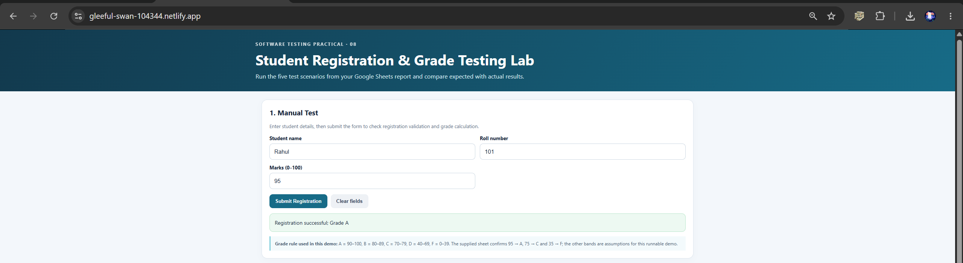

● Scenario ID: TC002
Scenario: Verify grade calculation for 75 marks
Test Steps:
- Enter student name
- Enter roll number
- Enter student marks
Test Input:
Name: Rahul
Roll No: 101
Marks: 75
Expected Result: Registration successful; Grade C
Actual Result: Registration successful; Grade C
Comments: Verifies the grade for 75 marks.
Screenshots:

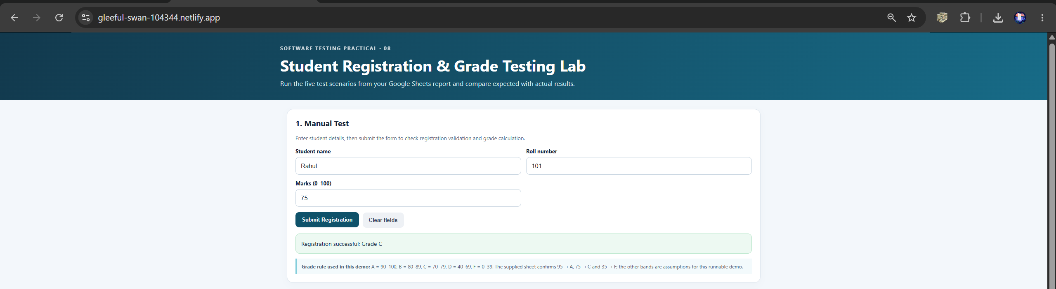

● Scenario ID: TC003
Scenario: Verify handling of negative marks
Test Steps:
- Enter student name
- Enter roll number
- Enter student marks
Test Input:
Name: Rahul
Roll No: 101
Marks: -5
Expected Result: Invalid marks
Actual Result: Invalid marks
Comments: Checks that negative marks are rejected.
Screenshots:

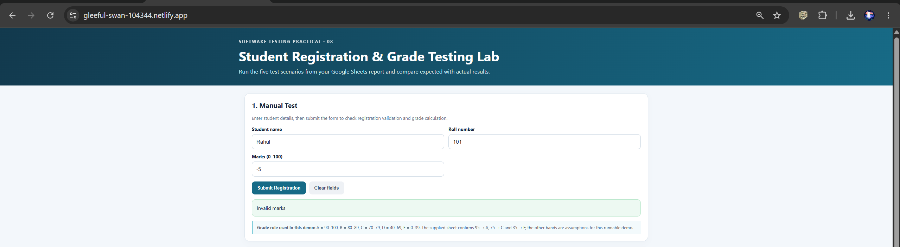
● Scenario ID: TC004
Scenario: Verify handling of a blank student name
Test Steps:
- Leave student name blank
- Enter roll number
- Enter student marks
- Submit the form
Test Input:
Name: Blank
Roll No: 101
Marks: 75
Expected Result: Student name cannot be blank
Actual Result: Student name cannot be blank
Comments: Checks required-field validation for the student name.
Screenshots:
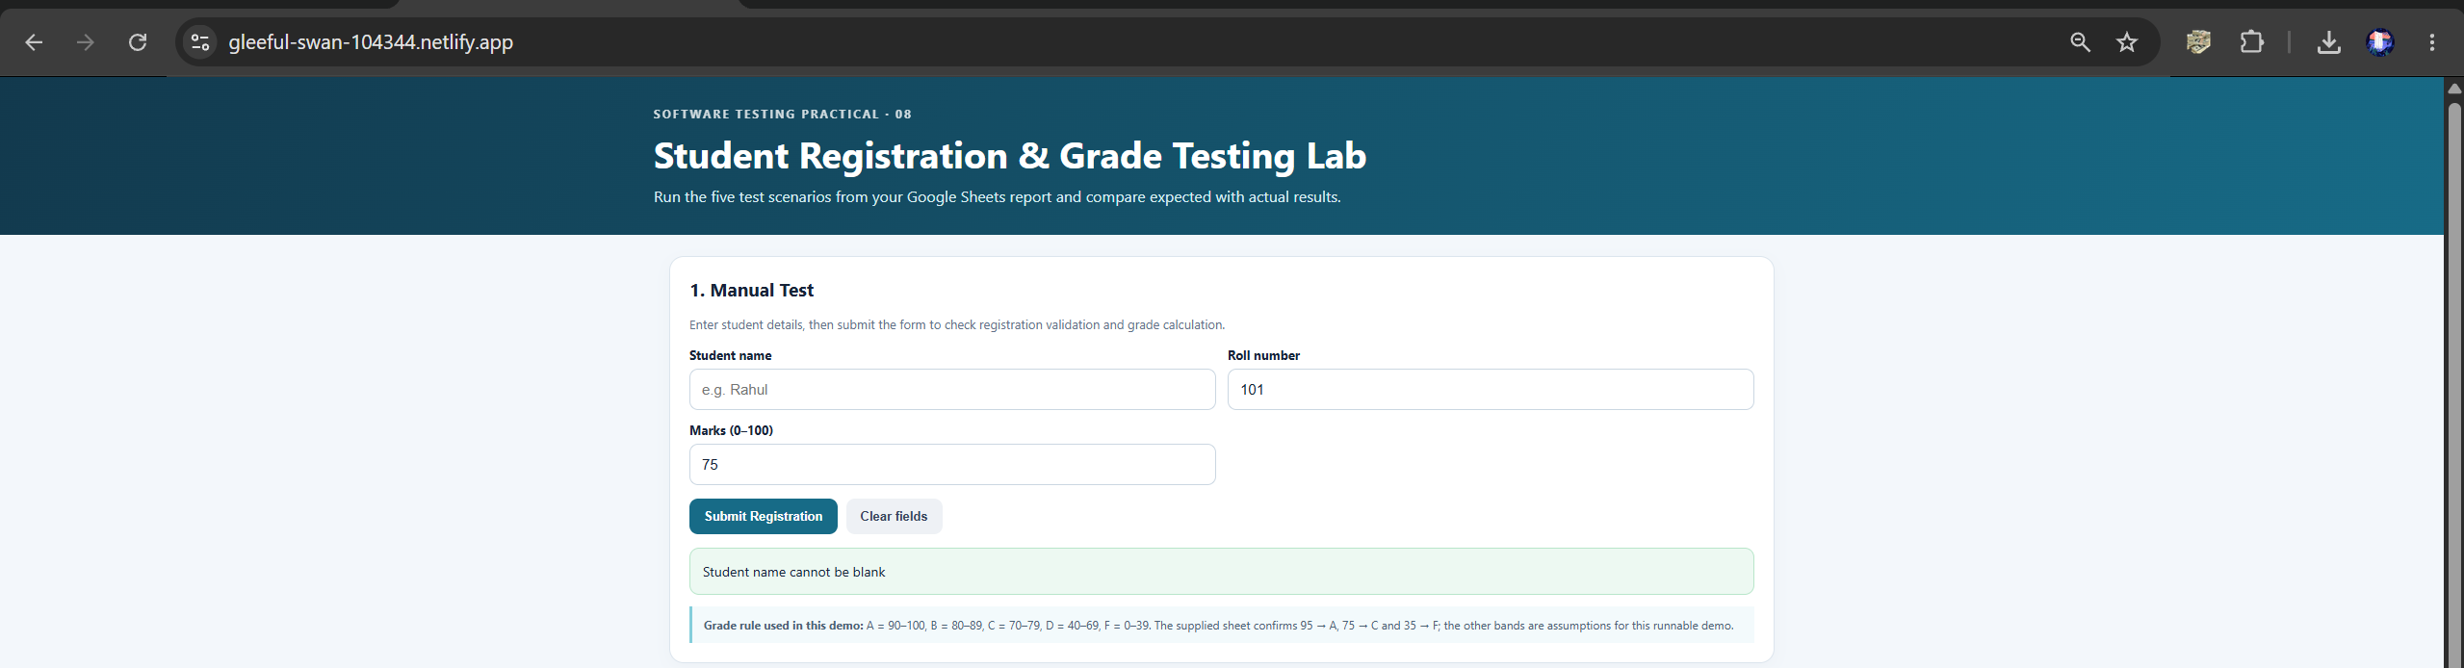

[Insert screenshot(s) for this scenario here]

● Scenario ID: TC005
Scenario: Verify grade calculation for 35 marks
Test Steps:
- Enter student name
- Enter roll number
- Enter student marks
Test Input:
Name: Rahul
Roll No: 101
Marks: 35
Expected Result: Registration successful; Grade F
Actual Result: Registration successful; Grade F
Comments: Verifies Grade F for marks below 40.
Screenshots:

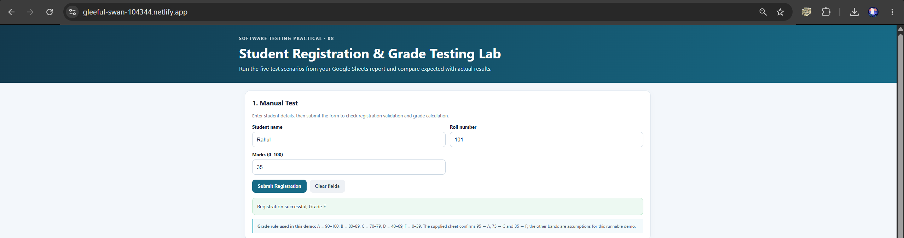
● Summary of Test Results:
- Total Test Cases: 5
- Passed: 5
- Failed: 0
- Pass Percentage: 100%
● Conclusion and Recommendations:
All five test scenarios produced the expected results according to the provided Google Sheets screenshot. The displayed grades for 95, 75, and 35 marks matched the expected results. Negative marks were rejected, and the blank student name was handled with a validation message.
Recommendation: Test additional boundary values such as 0, 39, 40, and 100 marks, along with marks above 100, to further verify grade calculation and input validation.
● Bug Reports:
No bugs are indicated in the supplied test results because the expected and actual results match for all five scenarios.

